

THE COPPERBELT UNIVERSITY  
SCHOOL OF INFORMATION COMMUNICATION TECHNOLOGY

Smart Bin: Reward-Based Waste Sorting  
System

Research Methodology  
  
**Done By**

Name: Bulaya Mwanaute

SIN: 20150307

Programme: Computer Engineering

**Supervised By**

Professor J. Mbale

# Table of Contents

Abstract 1

Declaration 2

Dedications 3

Acknowledgements 4

Table of Contents 5

List of Figures 6

List of Tables 7

Chapter 1: Introduction 1

1.1. Introduction 1

1.2. Background of Study 1

1.3. Problem Statement 1

1.4. Objectives 2

1.5. Hypothesis and Assumptions 2

1.6. Purpose, Scope and Applicability 2

1.7 Organisation of the Project 3

Chapter 2: Literature Review 4

2.1. Introduction 4

2.2. Related Work 4

2.2.1 Waste Sorting at the Disposal Stage 4

Current Practices and Technologies 5

Benefits of Sorting at the Disposal Stage 6

Challenges and Why It's Not Yet Widespread 6

Gaining Traction: The Path Forward 7

2.2.2 AI-Based Waste Classification 8

AI Methodologies in Waste Classification 8

Applications and Benefits 9

Challenges and Limitations 9

2.2.3. Reward-Driven Recycling 10

Types of Rewards and Incentives 10

Effectiveness and Benefits 10

Challenges and Limitations 11

2.2.4. Disposal Behaviour and User Incentives 12

Disposal Behavior 12

User Incentives 12

Smart Bin Placement 13

2.3. Previous Systems 13

2.4. References 13

Chapter 3: Research Methodology 18

3.1. Introduction 18

3.2. Methodology 18

Chosen Methodology: Agile with Hardware-Software Co-Design 18

Phases of Implementation: 18

System Development Approach 19

Tools and Technologies 19

3.3. Information Gathering And Analysis 19

3.4. Requirements Specification 19

3.4.1 User Requirements 20

3.4.2 System Requirements 20

Functional Requirements 20

Non-Functional Requirements 20

3.5. System Analysis 20

3.6. Conclusion 21

Chapter 4: System Design 22

4.1. Introduction 22

4.2. System Analysis 22

4.3. Context Model 22

4.4. Design Methods 22

4.4.1. Architectural Design 23

4.4.2. Detailed Design 25

4.4.3. Physical Design 25

4.5. Conclusion 25

# Chapter 3: Research Methodology

## 3.1. Introduction

This chapter outlines the research methodology adopted for the design and implementation of the AI-Driven Smart Bin for waste classification and sorting. It describes the selected development approach, the methods of gathering information, the analysis of current waste disposal practices, and the overall design and engineering strategy of the system.

Given the hardware-software integrated nature of this system—combining embedded electronics, artificial intelligence, and mechanical actuation—this study required both practical experimentation and iterative development. The Agile development methodology was selected to accommodate continuous improvement and modular prototyping.

To guide the design of the system, a custom dataset was created using images of the most frequently discarded waste items in the target deployment environments (e.g., campuses, restaurants, terminals). This was informed by observational research and informal interviews to understand local disposal habits.

This chapter includes the following components:

* Explanation of the chosen system development methodology (Agile)
* Approach to hardware-software co-design
* Information gathering and requirement analysis process
* Basis for selection of tools and technologies
* Initial description of experimental procedures and prototyping

## 3.2. Methodology

### **Phases of Implementation:**

1. **Conception Phase**Defined project scope: Develop a smart bin that uses AI to classify waste items and sorts them accordingly.  
   Early identification of system components and desired functionality.
2. **Setting Up**Defined required hardware (e.g. microcontroller, servo motors, camera module, ultrasonic sensor, coin dispenser, etc.)  
   Identified software tools and frameworks (e.g. YOLOv8 for detection, Python scripts, OpenCV for preprocessing, etc.)  
   Temporary use of an open-source detection dataset for model training; own dataset collection planned to begin shortly
3. **Design**

* High-level architecture was established.
* Modular hardware and software architecture designed.
* Visual representation of system architecture to be included here.

1. **Testability**

* Modules tested independently (e.g. servo motor control, ultrasonic readings).
* Classifier performance will be validated on unseen data from both borrowed and custom datasets.

1. **Implementation**

* Hardware assembly: mounting of camera, motors, and sensors into bin structure.
* Software implementation: real-time image classification and servo control logic.
* Model integration onto microcontroller or connected system (based on final resource evaluation).

1. **Verification**System behavior verification through structured testing scenarios:

* Correct detection and sorting of common recyclable items.
* Accurate detection of full bin state.
* Activation of bin lock and reward dispenser mechanism under correct conditions.

### **System Development Approach**

* Object-Oriented Analysis and Development (OOAD) was adopted for software modules, especially the classification and actuator control subsystems.
* Structured Analysis is applied to physical design and hardware flow (e.g. sensor-triggered actuation).

### **Tools and Technologies**

* Microcontroller: Raspberry Pi (for flexibility and compatibility with vision tasks).
* Software Stack: Python, OpenCV, PyTorch/YOLOv8, Flask (optional for local API), SAM (future for segmentation).
* Hardware Tools: 3D printed components, servo driver modules, power banks, USB camera.

## 3.3 Information Gathering And Analysis

To ensure the AI-Driven Smart Bin meets real-world needs and behaviors, multiple methods were used to gather both technical and user-centered information. These included literature review, field observation, behavioral surveys, and manual waste profiling.

#### **Literature Review and Background Research**

A comprehensive literature review was conducted to study existing smart waste systems, AI-based waste detection models, and environmental behavior trends. This helped identify challenges in public waste disposal, including low participation in recycling programs, contamination in waste streams, and limited adoption of automation in developing regions.

This also informed the feasibility of deploying lightweight object detection models such as YOLOv5 on embedded platforms, and helped refine the mechanical and AI design of the system.

#### **Survey on Local Waste Disposal Behavior**

To understand public behavior and the types of waste most commonly discarded in high-traffic locations (e.g. restaurants, bus stations, campuses), a structured survey was developed. The survey aimed to:

* Identify the most commonly disposed items
* Understand whether people sort their waste before disposal
* Assess public interest in reward-based recycling
* Determine ideal deployment locations for the system

Key survey questions included:

* Frequency of public waste disposal
* Types of waste most frequently thrown away
* Awareness of and participation in waste sorting
* Willingness to interact with smart bins
* Feedback on a reward-based incentive model

Respondents were also asked where they believed smart bins would be most useful. These insights directly guided the selection of classification categories — now focused on:

* Plastic bottles and containers
* Aluminum cans
* Paper and cardboard packaging

These waste types were confirmed to be highly prevalent in common public spaces such as schools, markets, and transportation terminals, unlike glass which was found to be more frequent in private establishments such as bars or restaurants with return policies.

#### **Site Observation and Waste Profiling**

Complementing the survey, informal observations were made in select locations such as a college cafeteria, a small shopping complex, and a bus station. Bins were monitored for volume, frequency of filling, and the types of materials disposed. It was observed that:

* Plastic bottles and food containers were the most frequently discarded
* Aluminum cans, especially from energy drinks and sodas, were common
* Paper waste, such as packaging wraps and receipts, was frequent near food courts and shops

Glass containers, while initially considered, were found to be infrequently discarded in the public areas observed. They are often returned, reused, or rarely sold in non-alcoholic form. This informed the decision to exclude glass from the system’s primary detection categories.

Photographs of disposed items were taken to build a real-world dataset, which is being used to train the object detection model for classification into the three supported waste types.

#### **Requirements Derivation and Stakeholder Needs**

Based on this analysis, a set of user and technical requirements were developed. These were later validated and adjusted during iterative prototyping. Requirements were derived from:

* Environmental concerns (e.g. reducing landfill waste, promoting recycling)
* User needs (e.g. simple and hygienic operation, fast response)
* Technical feasibility (e.g. object detection performance on microcontrollers)
* Feedback from potential users and deployment site managers

These insights informed the final waste categories, reward logic, and mechanical design, and formed the foundation for the Requirements Specification described in the following section.

## 3.4. Requirements Specification

This section outlines the user and system requirements for the Smart Bin. The system is designed to automatically classify and sort three common waste types — plastic, aluminum (metal), and paper — and incentivise responsible recycling behavior through a reward mechanism. The bin must detect when compartments are full and restrict use until emptied, ensuring clean and safe operation in commercial and public environments.

### **3.4.1 User Requirements**

The system must:

* Automatically identify whether a waste item is plastic, metal, or paper.
* Automatically sort each item into the correct compartment without requiring user input.
* Dispense a coin reward (or token) when an item is properly classified and accepted.
* Use lights and/or sound to indicate status (e.g., processing, error, full, idle).
* Lock the input lid and prevent use when any compartment is full to avoid overfilling.
* Be portable and powered by a power bank, not reliant on wall power.
* Classify and respond quickly, with minimal wait time for the user.
* Be safe, with no exposed moving parts, sharp edges, or electric shock risks.

### **3.4.2 System Requirements**

#### **Functional Requirements**

The system must be able to:

* Capture an image of the waste item using a camera module.
* Use an onboard AI object detection model (e.g. YOLO) to classify the item as plastic, paper, or metal.
* Optionally recognize unknown or generic waste items, and reject them.
* Rotate a motorized base/platform to align the correct compartment under the drop mechanism.
* Open a servo-based drop mechanism to release the item into the selected compartment.
* Dispense a coin or token only if the item belongs to a valid class.
* Detect whether a compartment is full using an ultrasonic sensor.
* Automatically lock the bin lid and disable input if the drop area is full.
* Provide feedback to the user using LEDs, screen, or buzzer (e.g., “Please Wait”, “Thank You”, “Bin Full”).
* Log item classifications or decisions for debugging or analytics (optional).

#### **Non-Functional Requirements**

The system should:

* Be cost-effective, built with affordable and widely available components.
* Run on a power bank, consuming low power during idle and active use.
* Complete the classification process in under 2 seconds.
* Complete sorting and reward operations within 5 seconds.
* Be robust and safe for unsupervised public deployment.
* Work in various lighting conditions (e.g., indoor classrooms, covered bus stops).
* Be maintainable, with easily removable compartments for emptying waste.
* Allow future updates to the AI model or software logic if needed.

## 3.5. System Analysis

System analysis is the process of decomposing and understanding the structure, components, and data flow within the proposed smart bin system. It helps refine the system requirements and provides a clear, graphical representation of how components interact. This analysis follows the Structured Analysis and Design (SAD) approach, using diagrams and flowcharts to model system behavior and data interactions.

The system is composed of both hardware and software subsystems that work together to achieve three key objectives:

* Detect and classify incoming waste
* Sort waste into the correct compartment
* Prevent overfilling and reward proper disposal

The following tools and diagrams are used for system analysis:

### **3.5.1 Use Case Diagram**

A use case diagram illustrates the key interactions between the system and its users (e.g. waste disposers, maintenance personnel).

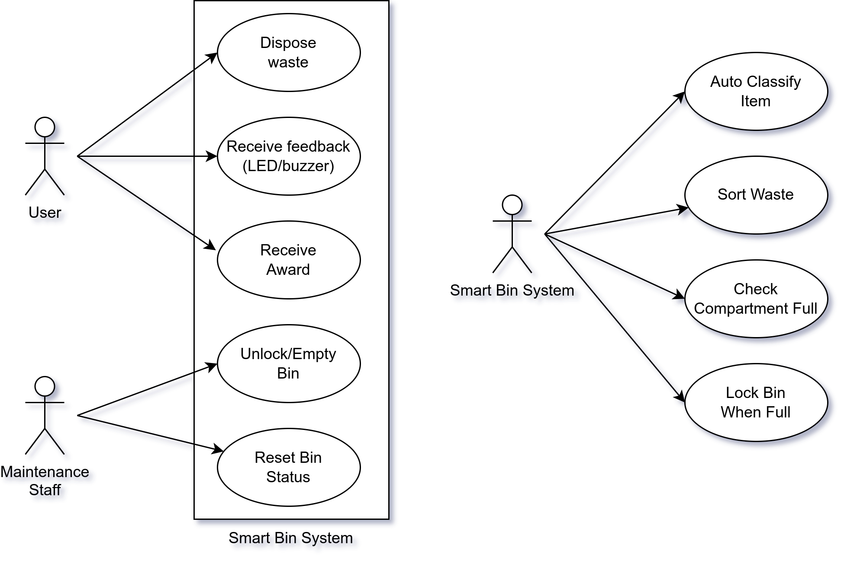

Figure 6: Smart Bin System use case diagram

### **3.5.2 System Flowchart**

This flowchart outlines the overall operation of the smart bin system, from input detection to classification, sorting, and reward dispensing.

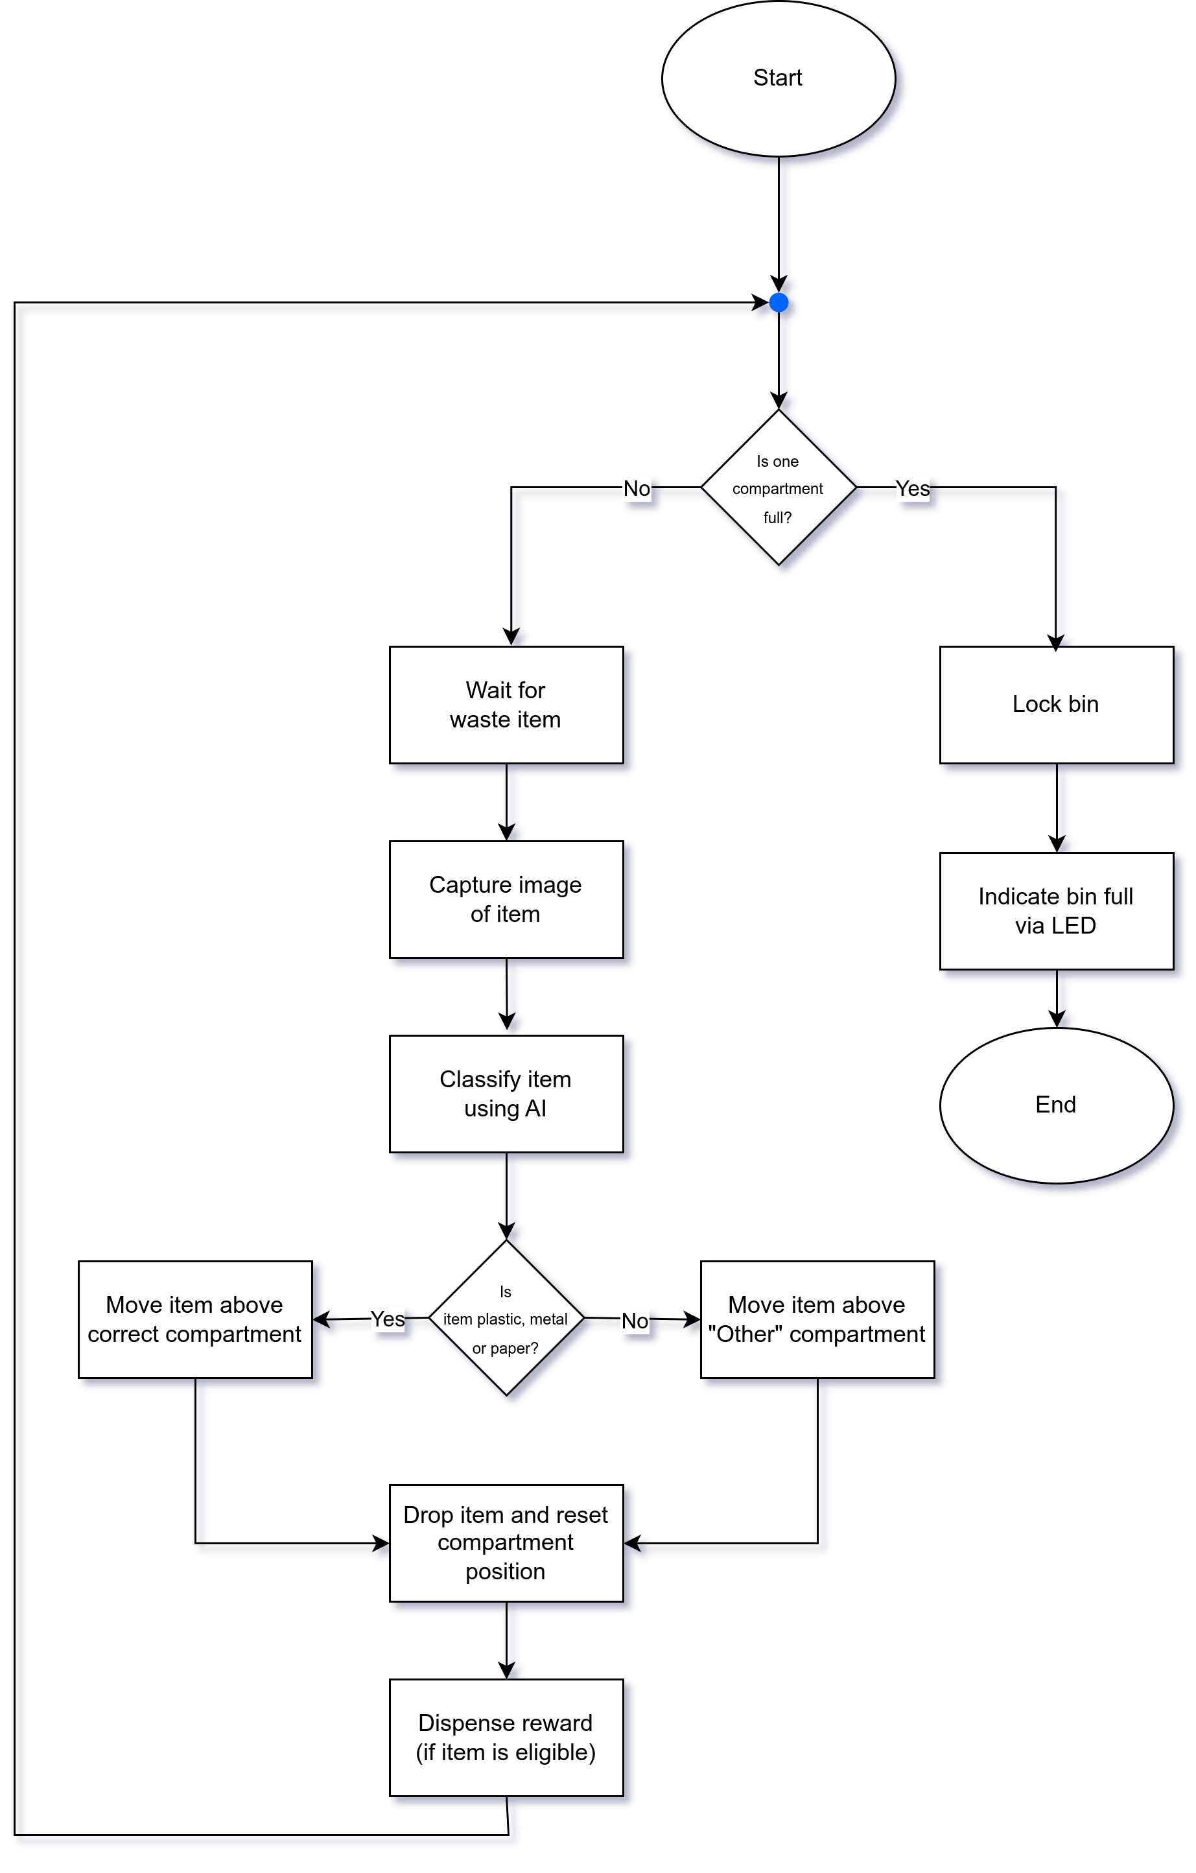

Figure 7: Smart Bin flow chart diagram

### **3.5.3 System Components and Interactions**

The system comprises the following key modules:

* Camera Module – Captures image of the object placed in the bin.
* Microcontroller – Acts as the system’s central control unit, running classification models and actuating motors based on decisions.
* AI Model (YOLOv5) – Classifies the object into one of the supported waste types: plastic, metal, or paper.
* Servo Motors – Control bin locking, platform rotation, and coin dispensing mechanisms.
* Ultrasonic Sensor – Detects whether a compartment is full.
* LEDs and Buzzer – Provide user feedback.
* Power Supply (Power Bank) – Portable power for all components.

The interaction between these modules is managed through firmware that runs on the microcontroller. Logic branches are designed to prevent operation when the bin is full and reward the user only if proper disposal is detected.

## 3.6. Conclusion

This chapter has presented the methodology adopted for the design and implementation of the AI-Driven Smart Bin system. It began by outlining the chosen development approach—Agile methodology—which supports the iterative nature of both hardware prototyping and AI model training. The chapter then detailed the information gathering process, including literature review, site observations, and user surveys, which collectively informed the system's requirements and design decisions.

User and system requirements were carefully specified to guide the integration of mechanical, electronic, and AI components. The system analysis section utilized structured analysis techniques and diagrammatic tools to break down the functional flow of the smart bin, including use case and process interactions.

Together, these activities have laid a solid foundation for the development and implementation phase, ensuring that the smart bin will be both technically feasible and aligned with real-world usage needs